STUDENTLIFECOACHING (StudentFlow) NEW WEBSITE
Website specifications
Newly developed StudentFlow website will mainly assist Student by managing their academic and personal lives effectively. The website include coaching in career guidance, bugeting,Daily planning, goal setting, motivation for students to make their students life and their personal life productive and fun.
StudentFlow Goals
- Help students manage their assignments and deadlines
- Improve study habits and time management
- Provide career path guidance
- Help reach financial balance through budgeting
- Motivate students by quotes and tips
Target audience
The target audience of this website is mainly students
Demographics:
- Age group 16-25
- High school and university students
- Both male and female
Technical Aptitude:
- Users have basic computer skills
- Able to browse websites and use simple online tools
- Familiar with smartphones and internet usage

Type of website
This website can be classified as special interest website (student support) because it focuses specifically on students life improvement and provides the following content:
- Day to day task planning tools
- Career guidance information
- Budgeting tools
- Study tips and advice
- Motivational content

Information design and Taxonomy
this website is designed in a way that information is grouped into clear sections so that users can easily find what they are looking for. Each section of the website focuses on a specific need of a student, such as studying, career guidance, budgeting
the homepage acts as a main entry point, where users can navigate to other pages using the menu. The content is organised in logical way to avoid confusion and improve user experience.
Site map

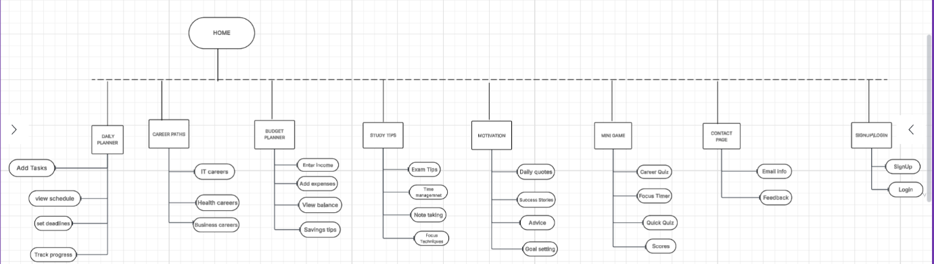

Navigation Paths
Users can move between pages using the navigation bar at the top of the website. All pages are connected, and users can return to the homepage at any time. The structure of the website follows a simple navigation flow, where users can access any page easily without going through many steps which means the 3 clicks rule is accounted for

Taxonomy
The website content is divided into the following categories:
- Academic support: study planner, study tips
- Career Development: career path section
- Financial Management: Budget planner
- Motivation and Engagement: Motivational and mini game

Technical Brief
Technologies used:
- HTML for creating the structure of the website
- Use of bootstrap
- CSS for styling and layout
- JavaScript for interactive features (budget tool and mini game)

Resources
Visual studio code for coding
GitHub for version control and storage
Canva or other tools for creating images

